# **Weekly Report – W4 Fall 2022**

## **Problem**

1. Derive the comprehensive governing equation by adding the interaction force (between human and soft robot) and the contact force (between soft robot and the environment, and it can be classified as impact and contact force further more).
2. Explore more potential methods that can estimate the contact force between the robot and environment rather than geometry and FEM approaches.

## **Assumption**

(1). From rigid robot to soft robot

* The model was set up based on the piecewise constant curvature theory, which means that the deformation will not affect the length of each segment of SRA;

(2). Human-robot interaction/collaboration force modelling

* The inertia tensor has very little influence on the interaction force, which can be ignored;

(3). Robot-environment impact/contact force modelling

Impact Stage:

* The impact process is instantaneous;
* There is no rebounding or slipping between the robot arm and the environment (grasped object) during impact;
* The external applied force can be represented by impulses during impact;
* The impulse forces may result in an instantaneous change in the velocities of robot arm, but no instantaneous change in their configuration (displacement or deformation).

Contact Stage:

* The contact surface is deemed to be a flat surface;

## **Solution**

### **1. The overall governing equation**

(1). *From rigid robot to soft robot*

The canonical format of the governing equation of **rigid robot** motion for the simplest case should be as follows if we temporarily do not consider what have been mentioned in Problem 1,

$$\begin{aligned}M_{R}\left(q\right)\ddot{q}+C_{R}\left(q,\dot{q}\right)\dot{q}+G_{R}\left(q\right)=τ_{A}\#\left(W4-1\right)\end{aligned}$$

where the subscript $R$ denotes soft robot, $M_{R}$ is the mass/inertia matrix, $C_{R}$ is the Centripetal-Coriolis matrix, $G_{R}$ is the vector of gravitational forces and $τ_{A}$ is the vector of robot joint torques or forces, which can be rewritten in another way,

$$\begin{aligned}τ_{A}=\left[\begin{aligned}τ_{AJ} \\ f_{AJ}\end{aligned}\right]\#\left(W4-2\right)\end{aligned}$$

However, for soft robot, apparently Eq. (W4-1) is not sufficient to depict its compliance, thereby two additional terms, namely, stiffness and damping matrices, should be added to the original model to represent the specification of soft material. If we assume the torsional stiffness of each robot arm link as $k_{u}$ and $k_{v}$, and the damping coefficients for twist and bending motion are $b_{u}$ and $b_{v}$ respectively, their potential energy for each part should be as follows,

$$\begin{aligned}P_{R-K,i}=\frac{1}{2}q_{i}^{T}\left[\begin{aligned}k_{u,i} \\ k_{v,i}\end{aligned}\right]q_{i}\#\left(W4-3\right)\end{aligned}$$

$$\begin{aligned}P_{R-B,i}=\frac{1}{2}{\dot{q}}_{i}^{T}\left[\begin{aligned}b_{u,i} \\ b_{v,i}\end{aligned}\right]{\dot{q}}_{i}\#\left(W4-4\right)\end{aligned}$$

If we bring Eq. (W4-3) and (W4-4) into Lagrange’s Equation, we can obtain the governing equation for the first step as follows,

$$\begin{aligned}M_{R}\left(q\right)\ddot{q}+C_{R}\left(q,\dot{q}\right)\dot{q}+G_{R}\left(q\right)+K_{R}\left(q\right)+B_{R}\left(\dot{q}\right)=τ_{A}\#\left(W4-5\right)\end{aligned}$$

where the stiffness matrix $K_{R}\left(q\right)=\frac{∂P_{R-K}}{∂q_{i}}$ and the damping matrix $B_{R}\left(q\right)=\frac{∂P_{R-B}}{∂{\dot{q}}_{i}}$.

(2). *Human-robot interaction/collaboration force assembly*

If we consider the interaction force between human and soft robot is in the form of force, the motion equation below should comply with most conditions if we assume the interaction is a mass-spring-damper system,

$$\begin{aligned}M_{R}\left(q\right)\ddot{q}+C_{R}\left(q,\dot{q}\right)\dot{q}+G_{R}\left(q\right)+K_{R}\left(q\right)+B_{R}\left(\dot{q}\right)=τ_{A}+f_{HJ}\#\left(W4-6\right)\end{aligned}$$

where the generalized interaction force for each joint is $f_{HJ}$ and $f_{H}=-C_{H}\dot{x}+K_{H}\left(x_{d}-x\right)$, in which the subscript $H$ stands for human, $J$ for joint of SRA, $C_{H}$ is the damping matrix of human body, $K_{H}$ is the stiffness matrix of human body, $x_{d}$ and $x$ are the human motion intention (or actual position) and position vector of the soft robot **base** respectively.

**Note:** In most papers, it is the end effector of the robot arm that has direct contact with human body, in this case we have to transform the variables $x$ under inertia frame into those under local frame of each joint/link by $f_{HJ}=J_{H}^{T}\left(q\right)f_{H}$ where $J_{H}^{T}\left(q\right)$ is the Jacobian matrix. But in our model, human body is tied with the base of SRA, the task space is to detect and interact with the environment, we can make the transformation in a similar way.

To sum up, the motion equation for this step will become

$$\begin{aligned}M_{R}\left(q\right)\ddot{q}+C_{R}\left(q,\dot{q}\right)\dot{q}+G_{R}\left(q\right)+K_{R}\left(q\right)+B_{R}\left(\dot{q}\right)=τ_{A}+J_{H}^{T}\left(q\right)\left[-C_{H}\dot{x}+K_{H}\left(x_{d}-x\right)\right]\#\left(W4-7\right)\end{aligned}$$

(3). *Robot-environment impact/contact force assembly*

When a human equipped with the SRA is walking freely without any potential tendency to fall down, the governing equation of the whole system will remain the same as Eq. (W4-7); if the tendency was detected (the specific strategies for recognizing falling down has not been determined yet), the “protection mode” will be triggered, the actuators in SRA will begin to work to let the arm grasp some firm objects nearby so that falling will be avoided, and Eq. (W4-7) still complies with this process.

However, when the SRA collides with the environment, the dynamics of the system will be switched to another mode, the contact mode. And the contact stage can also be classified into impact and contact (hold) modes. The logic inside can be organized in the way that based on Assumption 4 for this section, we can set a very small default tolerance $ε$ which can be seen as zero and be compared with the position variation $∆x_{I}$ of the impact point within a single sampling time, if $∆x_{I}≤ε$, it is deemed that collision occurs, from the next sampling time, the motion equation will be shifted to contact mode.

Stage 1: Impact

Firstly, for the impact stage, the dynamics can be deducted by Lagrange method as follows based on Eq. (W4-7),

$$\begin{aligned}M_{R}\left(q\right)\ddot{q}+C_{R}\left(q,\dot{q}\right)\dot{q}+G_{R}\left(q\right)+K_{R}\left(q\right)+B_{R}\left(\dot{q}\right)=τ_{A}+J_{H}^{T}\left(q\right)\left[-C_{H}\dot{x}+K_{H}\left(x_{d}-x\right)\right]+δM_{IJ}\#\left(W4-8\right)\end{aligned}$$

where $δM_{IJ}$ denotes the vector of external forces (actually impulse within a very small time span) acting on the robot joint due to impact/impulse between SRA and the environment. If we use the subscript $IC$ to present the collision point impact stage and $J$ to represent joint of SRA, for the superscripts $+$ and $–$ are instants after and before impact, according to conservation of momentum,

$$\begin{aligned}M_{R}\left(q_{IC}^{+}\right){\dot{q}}_{IC}^{+}-M_{R}\left(q_{IC}^{-}\right){\dot{q}}_{IC}^{-}=M_{IC}\#\left(W4-9\right)\end{aligned}$$

where $M_{I}=\int_{t^{-}}^{t^{+}}{δM_{I}\left(σ\right)dσ}$ and $q_{IC}^{+}=q_{IC}^{-}$.

As the velocity just before the impact is determined from the purely actuated stage (non-impact) and meanwhile the impact is much more likely to happen on other positions rather than the joints, we have to use analytical Jacobian to calculate the equivalent force/torque exerted on each joint by $f_{IJ}=δM_{IJ}=J_{A}^{T}\left(q\right)f_{IC}=J_{H}^{T}\left(q\right)\left[\begin{matrix}I & 0 \\ 0 & R^{-1}\end{matrix}\right]f_{IC}$, where $J_{A}\left(q\right)=\left[\begin{matrix}I & 0 \\ 0 & R^{-1}\end{matrix}\right]J_{H}\left(q\right)$ is the analytical Jacobian matrix, $f_{IC}$ and $f_{IJ}$ denote the impact force exerted on the contact point and joint respectively. We can also define $q_{IC}^{-}$ by the status of the base $q_{B}^{-}$ and their transformation (or rotation) matrix $R_{IC}$ as follows:

$$\begin{aligned}q_{IC}^{-}=\left[\begin{aligned}q_{B}^{-} \\ R_{IC}\left(q_{B}^{-}\right)\end{aligned}\right] ⟹ {\dot{q}}_{IC}^{-}=\left[\begin{aligned}I_{N×N} \\ \frac{∂}{∂q_{B}}R_{IC}\left(q_{B}^{-}\right)\end{aligned}\right]{\dot{q}}_{B}^{-}\#\left(W4-10\right)\end{aligned}$$

And then we can apply the principle of virtual work and let $p\left(q_{IC}\right)$ denote the position of contact point, we will obtain

$$\begin{aligned}M_{IC}=E{\left(q_{IC}^{-}\right)}^{'}f_{IC}\#\left(W4-11\right)\end{aligned}$$

where $E\left(q_{IC}^{-}\right)=E\left(q_{IC}\right)=\frac{∂p\left(q_{IC}\right)}{∂q_{IC}}$.

Next, according to assumption 2 aforementioned, we have

$$\begin{aligned}E\left(q_{IC}^{-}\right){\dot{q}}_{IC}^{+}=0\#\left(W4-12\right)\end{aligned}$$

Combining Eq. (W4-9), (W4-10), (W4-11) and (W4-12), we can derive

$$\left[\begin{matrix}M_{R}\left(q_{IC}^{+}\right) & -E{\left(q_{IC}^{-}\right)}^{'} \\ E\left(q_{IC}^{-}\right) & 0_{2×2}\end{matrix}\right]\left[\begin{aligned}{\dot{q}}_{IC}^{+} \\ f_{IC}\end{aligned}\right]=\left[\begin{aligned}M_{R}\left(q_{IC}^{-}\right){\dot{q}}_{IC}^{-} \\ 0_{2×1}\end{aligned}\right]$$

$$\begin{aligned}∴ \left[\begin{aligned}{\dot{q}}_{IC}^{+} \\ f_{IC}\end{aligned}\right]=\left[\begin{aligned}{\overline{∆}}_{{\dot{q}}_{IC}}\left(q_{B}^{-}\right) \\ ∆_{f_{IC}}\left(q_{B}^{-}\right)\end{aligned}\right]{\dot{q}}_{B}^{-}\#\left(W4-13\right)\end{aligned}$$

where ${\overline{∆}}_{{\dot{q}}_{IC}}=M_{R}^{-1}E^{'}∆_{f_{IC}}+\left[\begin{aligned}I_{N×N} \\ \frac{∂}{∂q_{B}}R_{IC}\left(q_{B}^{-}\right)\end{aligned}\right]$ and $∆_{f_{IC}}={-\left(EM_{R}^{-1}E^{'}\right)}^{-1}E\left[\begin{aligned}I_{N×N} \\ \frac{∂R_{IC}\left(q_{B}^{-}\right)}{∂q_{B}}\end{aligned}\right]$.

Thus the computed impact force acting on the contact point will be

$$f_{IC}={-\left(EM_{R}^{-1}E^{'}\right)}^{-1}E{\dot{q}}_{B}^{-}$$

$$\begin{aligned}∴ f_{IJ}=-J_{A}^{T}\left(q\right){\left(EM_{R}^{-1}E^{'}\right)}^{-1}E{\dot{q}}_{B}^{-}\#\left(W4-14\right)\end{aligned}$$

Therefore the motion equation for the impact process should be

$$M_{R}\left(q\right)\ddot{q}+C_{R}\left(q,\dot{q}\right)\dot{q}+G_{R}\left(q\right)+K_{R}\left(q\right)+B_{R}\left(\dot{q}\right)$$

$$\begin{aligned}=τ_{A}+J_{H}^{T}\left(q\right)\left[-C_{H}\dot{x}+K_{H}\left(x_{d}-x\right)\right]-J_{A}^{T}\left(q\right)\left\{{\left[EM_{R}^{-1}\left(q_{B}^{-}\right)E^{'}\right]}^{-1}E{\dot{q}}_{B}^{-}\right\}\#\left(W4-15\right)\end{aligned}$$

Stage 2: Contact

As all the external forces acting on the SRA obey the same rule in terms of the formatting in the motion equation, so as the contact force, and it is exerted on the end-effector of the SRA, we assume the Jacobian matrix mapping from task space to configuration space for this stage is $J_{E}\left(q\right)$, where the subscript E stands for environment. The governing equation will be:

$$M_{R}\left(q\right)\ddot{q}+C_{R}\left(q,\dot{q}\right)\dot{q}+G_{R}\left(q\right)+K_{R}\left(q\right)+B_{R}\left(\dot{q}\right)$$

$$\begin{aligned}=τ_{A}+J_{H}^{T}\left(q\right)\left[-C_{H}\dot{x}+K_{H}\left(x_{d}-x\right)\right]+J_{E}^{T}\left(q\right)f_{c}\#\left(W4-16\right)\end{aligned}$$

where $f_{c}$ is the contact force at end-effector. Then the force can be estimated by deformation and geometry factor of SRA as shown in the figure below (assuming the outer radius of the chamber is $R$ and the deformation is $d_{0}$),

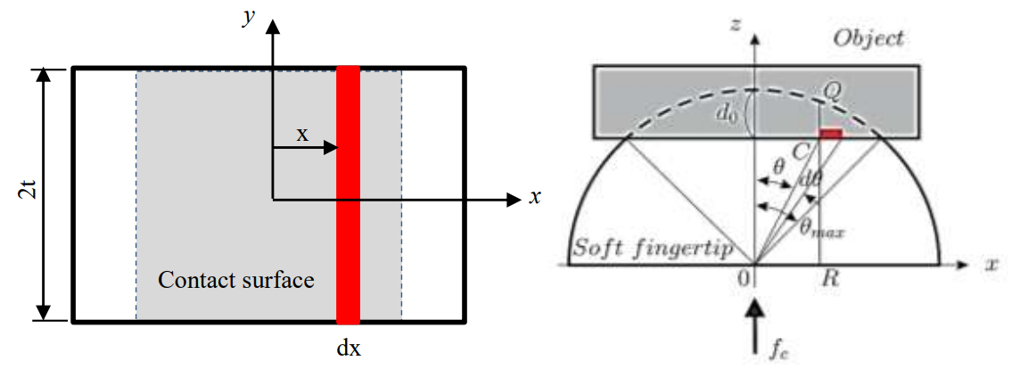

**Fig. W4-1** The contacting area of SRA

$$\begin{aligned}∴ θ_{max}=\tan^{-1}\left[\sqrt{\frac{R^{2}-{\left(R-d_{0}\right)}^{2}}{{\left(R-d_{0}\right)}^{2}}}\right]\#\left(W4-17\right)\end{aligned}$$

$$\begin{aligned}x=\left(R-d_{0}\right)\tan{θ} ⟹ dx=\frac{R-d_{0}}{\cos^{2}θ}dθ\#\left(W4-18\right)\end{aligned}$$

Therefore, the area of the contact surface can be calculated by

$$\begin{aligned}dS=2tdx=2t\frac{R-d_{0}}{\cos^{2}θ}dθ\#\left(W4-19\right)\end{aligned}$$

And then we can exploit this into a 3D problem as follows,

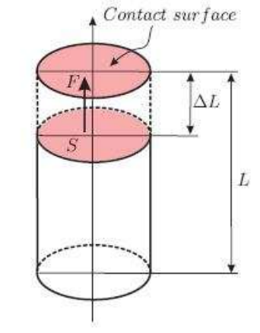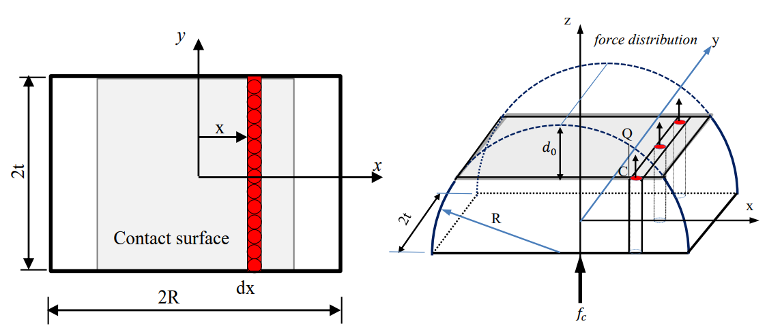

**Fig. W4-2** A model of semi SRA chamber based on force distribution

According to the definition of stress, we have

$$σ=\frac{F}{S} and E=\frac{σ}{e}$$

where $E$ is the Young’s Modulus of elasticity and $e$ is a dimensionless and being negative if stress is owing to compression, $e=\frac{∆L}{L}$.

$$\begin{aligned}∴F=PS=E\frac{∆L}{L}S\#\left(W4-20\right)\end{aligned}$$

where $∆L=\sqrt{R^{2}-{\left(R-d_{0}\right)}^{2}\tan^{2}θ}-\left(R-d_{0}\right)$, $L=\sqrt{R^{2}-{\left(R-d_{0}\right)}^{2}\tan^{2}θ}$. Then combining Eq. (W4-17), (W4-18), (W4-19) and (W4-20) results in:

$$\begin{aligned}f_{c}=\int_{S}{PdS}=\iint{Pdydx}=2tE∙2\int_{θ=0}^{θ=θ_{max}}{\frac{R-d_{0}}{\cos^{2}θ}dθ}=4tE\frac{d_{0}^{2}}{R-d_{0}}\#\left(W4-21\right)\end{aligned}$$

(4). *Summary*

Given the information above, the whole process can be summarized in the table below.

|  |  |  |
| --- | --- | --- |
| **Scenario** | | **Motion Equation** |
| Non-contact | | $$M_{R}\left(q\right)\ddot{q}+C_{R}\left(q,\dot{q}\right)\dot{q}+G_{R}\left(q\right)+K_{R}\left(q\right)+B_{R}\left(\dot{q}\right)=τ_{A}+J_{H}^{T}\left(q\right)\left[-C_{H}\dot{x}+K_{H}\left(x_{d}-x\right)\right]$$ |
| Contact | Impact/Collide | $$M_{R}\left(q\right)\ddot{q}+C_{R}\left(q,\dot{q}\right)\dot{q}+G_{R}\left(q\right)+K_{R}\left(q\right)+B_{R}\left(\dot{q}\right)=τ_{A}+J_{H}^{T}\left(q\right)\left[-C_{H}\dot{x}+K_{H}\left(x_{d}-x\right)\right]-J_{A}^{T}\left(q\right)\left\{{\left[EM_{R}^{-1}\left(q_{B}^{-}\right)E^{'}\right]}^{-1}E{\dot{q}}_{B}^{-}\right\}$$ |
| Hold/Grasp | $$M_{R}\left(q\right)\ddot{q}+C_{R}\left(q,\dot{q}\right)\dot{q}+G_{R}\left(q\right)+K_{R}\left(q\right)+B_{R}\left(\dot{q}\right)=τ_{A}+J_{H}^{T}\left(q\right)\left[-C_{H}\dot{x}+K_{H}\left(x_{d}-x\right)\right]+J_{E}^{T}\left(q\right)f_{c}$$ |

### **2. Other methods about modelling contact force**

(1). Spring-dashpot model

$$F_{n}=b\dot{δ}+kδ$$

(2). Hertz’s model

$$F_{n}=kδ^{n}$$

where $k$ and $n$ are constants depending on material and geometry properties and computed by using elastostatic theory.

(3). Non-linear damping

$$F_{n}=bδ^{p}{\dot{δ}}^{q}+kδ^{n}$$

where it is standard to set $p=n$ and $q=1$. For identifying $b$ and $k$, the relationship can be expressed by the coefficient of restitution as follows,

$$e=1-α{\dot{δ}}_{0} α=\frac{2b}{3k}$$

## **Difficulty**

1. For the impact stage, there could be multiple points that are “stationary”, the position change is temporarily the only way to judge if a certain point is impact point or not right now, which is not unique. So maybe some other constraints need to be considered to lock down the impact position.
2. Jacobian matrix for each stage seems different, as the interaction force between human and SRA is exerted on the base side, the grasp or hold force in the contact section can be seen as exerting at the end-effector, and the position of impact point can be arbitrary.
3. Modelling the contact force using methods provided in Part 2 heavily relies on the experimental data so that the universality has been weakened, more general modelling methods still need to be studied.

## **Plan**

1. For the contact force modelling section, we started from a very simple case that only considering the contact force along the radial direction, maybe in the near future we need to analyse its influence on tangential direction (friction).
2. Derive the Jacobian matrices, especially for the analytical one.